System Requirements Statement (SRS) –

Hotel Management System

Doc. Ref. : SRS_v0. 4. doc

Version : 0. 4

Status : Drafted

Created by : Kenji Tanaka

Date : 04-Dec-2012

1. Introduction 3

2. Functional Requirements 4

2. 1 Farmer Module 5

2. 2 Wholesaler Module 11

2. 3 admin Module 17

2. 4 message acknoeledgement Module 21

2. 5 Use Case Diagram. . . . . . . . . . . . . . . . . . . . . . . . . . . . . . . . . . . . . . . . . . . . . . . . . . . . . . . . . . . . . . . . . . . . . . . . . . . . . . . . . . . . . . . . . . . . . . . . . . . . . . . . . . . . . . . . . . . . . . . . . . . . . 22

THIS DOCUMENT CONTAINS 23 NUMBERED PAGES

# Introduction

This document explains the system requirements and scope for developing Hotel Management System.

Travel Nest could divide the three main parts, Hotel owner part, Customer part, Admin part.

This document describes the system requirement of the Account part.

# Functional Requirements

The Account part of Travel Nest has three modules which are divided 13 processes described as below.

|  |  |  |
| --- | --- | --- |
| **No** | **BRS requirement ID** | **Description** |
| **2. 1** | **Owner Module** | |
| **2. 1. 1** | **F1** | **Request for Registration** |
| **2. 1. 2** | **F2** | **Login Process** |
| **2. 1. 3** | **F3** | **Update Hotel** |
| **2. 1. 4** | **F4** | **View Booking** |
| **2. 1. 5** | **F5** | **Generate Bill** |
| **2. 1. 6** | **F6** | **View Feedback** |
| **2. 1. 7** | **F7** | **Check-In / Check-Out** |
| **2. 2** | **Customer Module** | |
| **2. 2. 1** | **F8** | **Account Creation Process** |
| **2. 2. 2** | **F9** | **Login Process** |
| **2. 2. 3** | **F10** | **Recover Password** |
| **2. 2. 4** | **F11** | **Browse Hotels** |
| **2. 2. 5** | **F12** | **Book Accommodation and Transportation** |
| **2. 2. 6** | **F13** | **Cancel Accommodation and Transportation** |
| **2. 2. 7** | **F14** | **Pay Bill** |
| **2. 2. 8** | **F15** | **Give Feedback** |
| **2. 3 Admin Module** | | |
| **2. 3. 1** | **F16** | **Login** |
| **2. 3. 2** | **F17** | **Approve / Deny Owner’s request** |
| **2. 3. 3** | **F18** | **Report Generation** |

## Owner Module

* Hotel Owners are the user of system who wants to display their hotels.

* He is also able to view the market prices of hotels.

### Request for Registration

* Hotel Management System compels to create the account before using it. So, Hotel Management System should provide the function which makes customers to create new account.
* When customer creates new account, the function demands two information described as below.

1. Login information
2. Contact Detail
3. Authentication

* The Login information

The Login information consists of some items described as below.

1. E-mail
2. Password
3. First Name
4. Last Name
5. E-mail address
   * All items are compulsory demanded.
   * E-mail

* The E-mail should be unique. If the E-mail correspond with not case-sensitive to other which is previously registered, the E-mail should not be registered as an account.
  + Password
* The Password has constrains which makes the Password consists of more than or equal 8 and less than or equal 16 characteristics including characters described as below.

1. Numeric figure (at least one)
2. Capital alphabet (A-Z)(at least one)
3. Small alphabet (a-z)(at least one)
4. Special character (#, $, %, &, etc. ) (at least one)

* The Password is masked by dummy characters. The re-entering Password is demanded.
  + User Type

The User Type falls into two categories described as below.

1. Room booking
2. Room booking with Transportation service

* The User Type defines also three types of user; "Customer user", "Hotel Owner user", and "Administrator user”.
* In an Account Creation Process, the user can select Hotels and Transport service.
* No one could select The Administrator, because Administrator is implemented to Hotel Management System in advance.
* Contact Details
* The Contact Detail consists of some items described as below.

1. Hotel Address
2. Contact Phone No
   * All items are compulsory demanded.
   * Hotel Address

* Hotel Address should be filled.
* But only the state should be selected from options.
* Authentication Details

1. Hotel License ID
   * All items are compulsory demanded.

### Login Process

* Hotel Management System always compels user authentication before using itself except when a new account is successfully created.
* The Hotel owner authentication demands E-mail and Password. The E-mail and the Password should be checked in three ways.
  + First, The E-mail and the Password should be existed and correct.
* If The E-mail and the Password are not equal to what the user has registered, the user authentication cannot be provided.
  + Second, the User Type linked to the E-mail should be "Hotel Owner".
* When the User Type is "Hotel Owner", then user can be placed on “Hotel Owner”.
  + Finally, E-mail should be available.
* The Administrator can decide whether the E-mail is available or suspended – Refer to the SRS of the Admin part.
* If Hotel Owner is rejected, user authentication is not provided for system user.
* Only when the three checks are successfully completed, Hotel Owner can be placed on respected page.
* The “Hotel Home” provides the some items described as below.

1. A trigger to logout
2. A trigger to update Account
3. A trigger to Change Password
4. A trigger to Search Hotel
5. A trigger to Publish Hotel for booking
6. A trigger to Update Hotel Information
7. A trigger to Delete Hotel
8. A trigger to Browse existing Market price

### Update Hotel

* Hotel Management System should provide the function which makes the account updated for Owners.
* The information Hotel Owners could update is described below.

1. Login information
2. User information

* The Login information

The updatable items as described below.

1. First Name
2. Last Name
3. E-mail address
   * All items are compulsory demanded, but updating is optional.

* The User information

The updatable items as described below.

1. User Name
2. User Phone No
3. E-mail address
   * All items are compulsory demanded, but updating is optional.

* The Authentication Process

1. Hotel License ID
   * All items are compulsory demanded, but updating is optional.

#### Publish Cab Service

* **Purpose** - This system will facilitate seamless booking and management of cab services for hotel guests, ensuring efficiency, convenience, and enhanced guest satisfaction.
* **Scope:** It will enable guests to book cabs directly through the hotel's platform.
* User can choose the destinations for transportation service :

1. Bus stand to hotel
2. Railway station to hotel
3. Airport to hotel

#### Publish Room for Booking

* After publishing the Hotel the Hotel Owners can only update following contents.

1. Room Type
2. Room price.
3. Room booking with transportation service
4. Hotel owners will update details such as hotel amenities, room descriptions, pricing, availability, contact information, and policies. The system will be accessible via a secure web interface and will integrate with existing hotel management and booking platforms.

#### Availability Room

* The Room availability feature will be a component of the hotel management system that allows hotel owners to manage their room availability.
* The system will be accessible via a secure web interface and will integrate with existing hotel management and booking platforms.

#### 2.1.4 View Booking

1. **Detailed Booking Information**

Owners should be able to view detailed information about each booking, including:

* **Guest Details**: Name, contact information, and any special requests.
* **Booking Details**: Dates of stay, room type booked, transportation service avail or not, and rate details.
* **Payment Status**: Whether payment has been received.

1. **Dashboard Overview**

Owners usually have a dashboard upon logging in that provides an overview of the property's current status

* **Occupancy**: Current and upcoming bookings, occupancy rates.
* **Financial Summary**: Revenue generated and financial projections.
* **Guest Feedback**: Summaries of guest reviews and ratings.

1. **Manage Booking**

* **Approving or Rejecting Bookings**: Especially relevant for direct booking requests or special requests
* **Modifying Bookings**: Changing dates, upgrading rooms.

### 2.1.5 Generate Bill

**2.1.5.1** **Gather Necessary Information**

# Room Details: Type of room occupied, duration of stay, and any special requests or services used.

1. **Stay Details**: Dates of check-in and check-out.
2. **Services Opted**: Whether the transportation service avail or not. If yes, then extra changes will be counted.

**2.1.5.2Calculate Charges:**

* **Room Charges**: Calculate the room rate multiplied by the number of nights stayed.

• **Additional Services**: Include charges for any additional services used, such as transportation service.

* **Taxes and Fees**: Apply applicable taxes (e.g., sales tax, city tax, resort fees) to the subtotal of charges.

**2.1.5.3Payment Information:**

* **Accepted Payment Methods**: Specify which payment methods are accepted (e.g., credit cards, cash).

**Hotel Policy :**

Hotel policies are guidelines and rules established by hotels to ensure smooth operations, maintain guest satisfaction, and clarify expectations for both guests and Owner.

1. Booking **Policies**

* **Booking Procedures**: How guests can make reservations (online, phone, walk-in).
* **Cancellation Policy**:

Rules regarding cancellation deadlines, penalties, and refunds.

* **Booking cancellation should be accelerate before 48 hrs. If not done, then 2% will be deducted from paid amount.**
* **Refund amount will be credited within 7 working days.**

1. Check-In and Check-Out

* **Check-In Time**: Standard check-in time and flexibility (if any).
* **Check-Out Time**: Standard check-out time and late check-out options (if available).

### 2.1.6View Feedback

* This will enable hotel owners to access guest feedback and manage common questions and answers.
* It will be accessible via a secure web interface.
* Enable hotel owners to create, update, and delete FAQ entries.
* Organize FAQs into categories for easy navigation.
* Provide an interface for guests to view FAQs on the hotel's website.

### 2.1.7 Check-In/Check-Out

1. The Check-In and Check-Out System will allow hotel staff to manage guest arrivals and departures efficiently.
2. The system will be accessible via a secure web interface and will integrate with existing hotel management and booking platforms.
3. Manage guest check-ins and check-outs.
4. Assign rooms to guests.
5. Update room status (e.g., occupied, vacant).
6. Record and manage payments.

**Check-in -**

1. The system shall allow staff to search for reservations by guest name, reservation number, or date.
2. The system shall display reservation details, including guest information, room type, and special requests.
3. The system shall allow staff to assign rooms to guests based on availability.
4. The system shall update room status to "occupied" upon check-in.
5. The system shall provide an option to print check-in confirmation

**Check-out -**

1. The system shall allow staff to search for checked-in guests by name, room number, or check-in date
2. The system shall display the guest's stay details, including billing information and any outstanding charges.
3. The system shall allow staff to generate and print invoices for guests.
4. The system shall update room status to "vacant" upon check-out.
5. The system shall provide options to record payments and close the billing account.
6. The system shall notify housekeeping to clean the vacated room.

## Customer Module

#### 2.2.1 Account Creation Process

* Travel Nest compels to create the account before using it. So, Travel Nest should provide the function which makes customer create new account.
* When Customer creates new account, the function demands four information described as below.

1. Login information

2. Contact Details

3. Security Question Information

4. Payment information.

* The Login information

The Login information consists of some items described as below.

* 1. E-mail address
  2. Password
  3. Confirm Password
  4. First Name
  5. Last Name
  + All items are compulsory demanded.
  + E-mail address
* E-mail Address will be consider as user ID
  + Password
* The Password has constrains which makes the Password consists of more than or equal 8 and less than or equal 16 characteristics including characters described as below.

1. Numeric figure (at least one)

2. Capital alphabet (A-Z )(at least one)

3. Small alphabet (a-z )(at least one)

4. Special character (#, $, %, &, etc. ) ( at least one)

* The Password is masked by dummy characters. The re-entering Password is demanded.
* The Password must be encrypted in Travel Nest.
* Confirm Password
* Re-enter password. This password should match above password field
* Contact Details

The Contact Detail consists of some items described as below.

1. Permanent Address

2. Contact Phone No

* + All items are compulsory demanded.
  + Permanent Address
* Permanent Address should be filled.
* But only the state should be selected from options.
* The Security Question information

The Security Question information is needed when Customer lost their Password. This information consists of two items described as below.

1. Selected Question
2. Answer
   * All items are compulsory demanded.
   * Some questions which are difficult to answer for anyone else are prepared in advance.

E. g. which color do you like most?

* + A question should be selected from options by the Customer, and the Answer is registered by the Customer.
* Login information should be entered on one screen, and then Customer information and Security Question information should be entered on another screen.

#### Login Process

* Travel Nest always compels Customer authentication before using itself except when a new account is successfully created.
* The user authentication demands E-Mail ID and Password. The E-Mail ID and the Password should be checked in two ways.
* First, The E-Mail ID and the Password should be existed and correct.
* If The E-Mail ID and the Password are not equal to what the user has registered, the user authentication cannot be provided.
* The Customer account should alive for so long as the duration decided by Admin.
* Only when the two checks are successfully completed, Customer can be placed on respected page.
* The “Customer Home” provides some items described as below.

1. A trigger to logout
2. A trigger to update Account
3. A trigger to Change Password
4. A trigger to Search Rooms
5. A trigger to Update Product Information
6. A trigger to Cancel Booking
7. A trigger to Browse existing Market price

#### Recover Password

* When Customer lost their Password, the recovery method should be provided by Travel Nest.

The recovery method is described as below.

* + First, Customer enters their Email ID for logging in.
  + Next, the System demands the Answer which has been registered since when the Account was created.
  + Only when the Answer is correct, Customer will get the new password by E-mail which also has been registered since when the Account was created.
  + Then new password is entered by Customer.
* Of course, the new password should consist of more than or equal 8 and less than or equal 16 characteristics including at least a numeric figure, a capital alphabet, a small alphabet, and a special character. This
* As a consequence, The Customer could get the user authentication using the new password.
  + Then, the Customer had better change the new password manually.
* If the Answer is not correct, otherwise, the correct Answer is demanded for Wholesaler again.
  + In that case, Of course, Customer couldn’t get the new password.

### Browse Hotel

• Customer could see the list of hotels which are available for booking.

1. Hotel name

2. Price

3. Room type

4. Photos

#### Book Accommodation and Transportation

As a result of searching Hotel and selecting any one out of them, Customer will able to see following Hotel details.

1. Hotel Details:

* Hotel Name
* Booking Time(check in & checkout)
* About Hotel and Amenities
* Feed Back & Rating
* Property Rules
* Cancellation Policy
* Hotel Location

1. Select Room:

* Multiple Rooms with prices
* Images and details

1. Car Booking:

If Hotel are providing car services facility.

* Car Type
* Source to Destination
* Timing

Customer can select room type and car type.

### Cancel Accommodation and Transportation

* Customer can cancel bookings depending upon the hotel policies. On cancellation of booking, as per policies payback process will initiate. Feedback or Grievance can be submitted.

### Pay Bill

* Pay bill via Credit card, Debit card, Net Banking on confirmation of Booking.
* Payment can be done via cash.

### Feedback

* The user can provide his/her experience in this section.

## Admin Module

**•** Administratorshould be responsible for following activities**,**

### Login Process

* Travel Nest always compels user authentication before using itself except when a new account is successfully created.
* The user authentication demands Email ID and Password. The Email ID and the Password should be checked in three ways.
  + First, The Email ID and the Password should be existed and correct.
* If The Email ID and the Password are not equal to what the admin has registered, the Admin authentication cannot be provided.
  + Second, the User Type linked should be "Admin".
* When the User Type is "Admin", user can be placed on “Admin Home”.
* The Admin account should alive for so long as the duration decided by Admin.
* Only when the two checks are successfully completed, Admin can be placed on respected page.
* The “Admin Home” provides the some items described as below.

1. A trigger to Login/Logout
2. A trigger to Forgot Password
3. A trigger to Change Password
4. A trigger to Search Hotel
5. A trigger to Delete Hotel
   * 1. **Login/Logout**

• Admin must login using a Email ID and Password.

• The system should verify credentials and grant access if valid.

### Forgot Password Process

* When Admin lost their Password, the recovery method should be provided by Application.

The recovery method is described as below.

* + Admin will enter the User ID created, since when the Account was created.
  + After entering the User ID correctly, application will redirect Admin to Change Password Process.

### Change Password Process

* The Application will provide a feature for the Admin to change their password when desired.
* Therefore, Application will provide the function which is available after getting the Admin authentication.
* The function demands the current password and the new password.
  + The new password should consist of more than or equal 8 and less than or equal 16 characteristics including at least a numeric figure, a capital alphabet, a small alphabet, and a special character.
  + The current password and the new password are masked by using dummy characters.
  + The new password is demanded to enter twice to avoid a typing error.
* Only when the current password is correct, Admin could change his Password.
* When the current password is changed into new password, Application compels user authentication again.

### Hotel Management

• Admin should able to manage all the accounts with following activities,

1. Enable Hotels

2. Disable Hotels

### Record Generation

• Admin should able to see all the records from any users.

• Daily report of enrolment to admin.

• Monthly report of enrolment as per the states to admin.

### 2.3.3. ****Consult Relevant Information:****

* **Gather necessary data.** gather additional information or consult relevant documentation to inform decision about request acceptance .

### ****5.Make the Decision:****

* **Approve or deny.** Based on your assessment, decide whether to approve or deny the owner's request.

### 6. ****Follow Up:****

* **Monitor outcomes.** After the decision, monitor the impact and follow up as needed to ensure everything proceeds as expected.

This process helps ensure that decisions are well-informed and communicated effectively.

**2.4 Report Generation**

This report provides an overview of the current status and management of [Hotel Name]. It includes an analysis of Rooms availability, Transportation service availability, and recommendations for improvement.

**Overview:**

* **Hotel Name:** [Hotel Name]
* **Location:** [City, Country]
* **Current Status:** [Availability of Rooms and Transportation Services]

**Operational Overview:**

* **Occupancy Rates:**
  + Average Occupancy Rate:
  + Seasonal Variations:
  + Future Booking:

• **Customer Satisfaction:**

* Guest Feedback:

**Guest Services and Facilities:**

* **Room Facilities:**
  + Types of Rooms:
  + Transportation Service

**Conclusion:** In conclusion, [Hotel Name] is currently performing well in terms of revenue generation and guest satisfaction. By implementing the recommendations provided, [Hotel Name] can further strengthen its position in the competitive hospitality industry.

**Appendix:**

* Additional Data Tables or Charts
* Detailed Financial Statements (if applicable)

This report is intended to provide a comprehensive overview for stakeholders and management to make informed decisions regarding the future direction and management of [Hotel Name].

#### 2. 5 Use Case Diagram

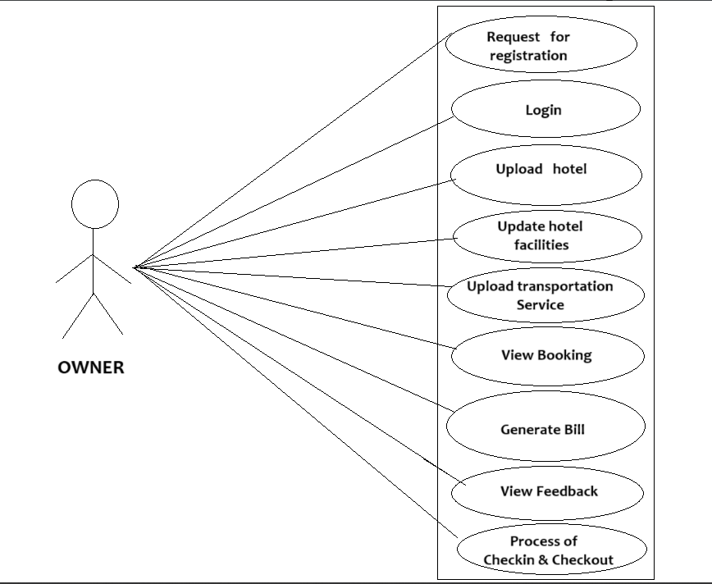

*Fig. Use case diagram for Owner*

**Owner:**

1. In Owner use case diagram Farmer is the Actor.
2. Farmer can handle following use cases:
3. Register
4. Login
5. Upload Hotel
6. Update Hotel Facilities
7. Upload Transportation Services
8. View Booking
9. Generate Bill
10. View Feedback
11. Checking & Checkout Process

**Customers:**

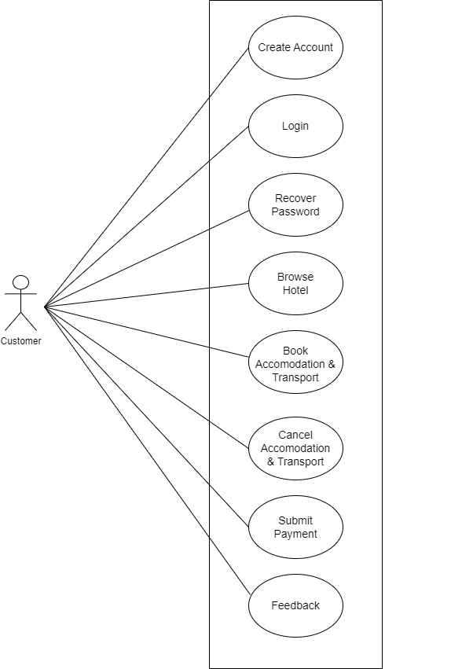

*Fig. Use case diagram for Customers*

1. In Customer use case diagram Customer is the Actor**.**
2. Customer can handle following use cases:
3. Create Account
4. Login
5. Recover Password
6. Browse Hotel
7. Book Accommodation and Transport
8. Cancel Accommodation and Transport
9. Submit Payment
10. Feed Back

**Admin:**

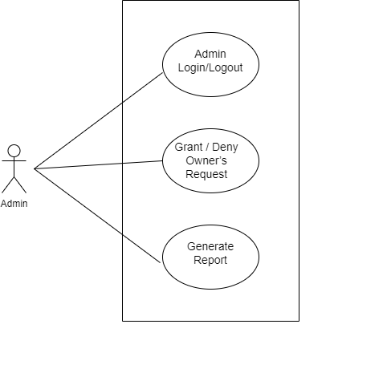

*Fig. Use case diagram for Admin*

1. In Admin use case diagram Admin is the Actor.
2. Admin can handle following use cases:
3. Admin Login/Logout
4. Grant / Deny Owner’s Request
5. Report Generation

2.3.Approve / Deny Owner’s Request

1. **Review the Authentication:**

**Understand the request clearly.** And authenticate the owner, with the help of Hotel License ID. Ensure you understand what the owner is asking for and any specifics related to the request.

### ****2.Assess the Impact:****

### **Evaluate the implications.** Consider how approving or denying the request will affect the project and operations involved.

### 3. ****Consult Relevant Information:****

* **Gather necessary data.** If needed, gather additional information or consult relevant documentation to inform your decision.

### ****4.Consider Alternatives:****

* **Explore options.** If denying the request, consider alternatives or compromises that could be proposed to meet the owner’s needs.

### ****5.Make the Decision:****

* **Approve or deny.** Based on your assessment, decide whether to approve or deny the owner's request.

### 6. ****Communicate Effectively:****

* **Provide clear reasoning.** Communicate your decision clearly to the owner

### 7. ****Follow Up:****

* **Monitor outcomes.** After the decision, monitor the impact and follow up as needed to ensure everything proceeds as expected.

This process helps ensure that decisions are well-informed and communicated effectively, fostering transparency and clarity in project management or ownership situations.